In AngularJs , services are reusable singleton objects that not only seperates logic from controllers but also used to share logic across the application, be it controllers or other services.
These services can be injected into other services or controllers through dependency injection by passing them as parameters to the function.

AngularJs provides three data access services :
Providers, service and factory.
Providers are services that are used to configure an object before the object gets created. This is done during the config phase while the application is being initialized.
Directives :
Directives are custom HTML elements.
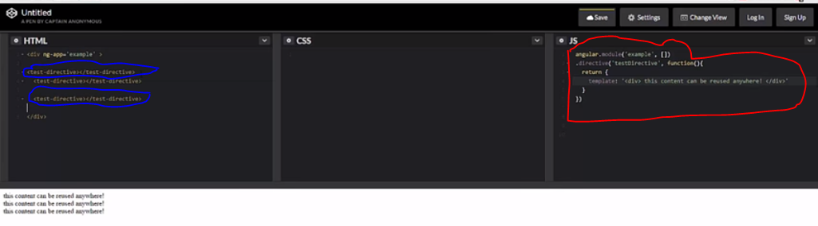

The red encircled part shows how we create a directive and the blue encircled part shows how we use this directive like any other thml element.
NOTE : each of these directives will have their own scope and controllers associated with them.
Directives allows us to declare an entire HTML compnent in a single object.
IT allows us to augment to an existing HTML element
It serves as a container for other directives thereby eliminating the need for controller.
Directives can be attached to as many HTML components as possible so it increases reusability throughout the application. Directives can be added to other directives as well and offer the best way for DOM manipulation.

WE use directives in two ways:
- Using directive as an HTML element.
Ex: <my-directive> </my-directive>
- Using directive as an attribute to already existing HTML element.
Ex: <div my-directive></div>
When compiling directives, angular takes a look at the directive name ie. my-directive and camel cases it to myDirective. Here the compiler looks at – (hiphen) for camel-casing.

Constructing directives :
Var app =angular.module(“myModule”);
App.directive(“myDirective”,function(){
restrict: 'A',
require: '^anotherDirective',
scope: {
value1: '@'
},
template: template: '<div><h4>Template for directive {{thisController.directivename}}</h4></div>',
link: function(scope,elem,attrs){
},
controller : function(){
this.directivename=”myDirective”
},
controllerAs : “myController”

});
Link accepts three attributes : scope for accessing this directives local scope object.
Element, for accesing this directive element’s DOM and
attr , for accessing the attributes passed to this directive.
Attributes can be passed into Directives by including them as separate HTML attributes.
<sample-directive attribute-value='1'>
</sample-directive>
link: function(scope, elem, attrs) {
var therecanbeonly = attrs.attributeValue;
}
Tip Access Scope values via attributes by making use of the scope.$eval() function. THIS IS NOT THE SAME as JavaScript eval(). JavaScript eval() takes a string and interprets it as JavaScript, which is highly dangerous, since any content could be injected into the function and evaluated as valid script. scope.$eval(), on the other hand, takes the value you pass to it and attempts to locate it in the broader scope. Using scope.$eval() is a significantly less dangerous activity because it cannot contain arbitrary code. It is useful to pass values from the scope into the link function in this manner.
<sample-directive attribute-value='directivename'>
</sample-directive>
link: function(scope, elem, attrs) {
var nameofdirective = scope.$eval(attrs.attributeValue);
}
controller: function($scope){
$scope.directivename = 'sampleDirective';
}

Link is used , to evaluate the attributes passed to it, isolating the logic specific to this directive, communicating with other directives, modifying DOM.
Next is controller and controllerAs. Using a function in the controller attribute is the same as putting an ng-controller declaration on the element within the template and writing a separate controller. All of the same rules that normal controllers have also apply to Directive controllers. Dependencies can be injected directly into the controller function definition for use within the controller. The controllerAs variable assigns a name to the scope from the controller just as using the controller as syntax in ng-controller.

Note: When using the controllerAs in a Directive, bind values to this in order to expose them to the template.

SCOPE
ISOLATED SCOPE

uiBootstrap :

ngAnimate :

Configuring Angular modules:
Config and Run Blocks
Configuration of your Angular application can be performed in one of two places, the Config Block or the Run Block. This allows you to set basic information that the rest of your application will be able to consume.
Variables set here can control the inner workings of Angular, as well as other Modules you may have included as a dependency.
The config Block of the application can control many of Angular's built-in services. Below, you see the providers that control $http, $location, $compile, $filter, and $route, as well as reference to a custom Provider and a custom Constant (more on Providers in the next section). Config Blocks are also where routing is defined, which you will learn in subsequent sections.
angular.module('crazydeveloperModule', [])
.config(['$httpProvider','$locationProvider','$routeProvider', '$provide', '$compileProvider', '$filterProvider','someProvider','someConstant',
function ($httpProvider, $locationProvider, $routeProvider, $provide, $compileProvider, $filterProvider, someProvider,someConstant) {

//You can only inject providers into config blocks.
//You can inject constants.
//But you cannot inject services or factories as they are not ready by the time this executes.

//Here's an example of a change to the configuration of the $http service.
$httpProvider.defaults.headers.common.Authorization = 'Basic YmVlcDpib29w';

}])
The run Block of the application has access to the rootScope, as well as any services or factories that have been created. This is the best place to execute code that needs to be run as soon as the application is initialized; for instance, with any authentication logic, or event handlers that need to be bound immediately.
angular.module('myModule', [])
. run(['$rootScope','authentication','someFactory','$httpBackend',
function ($rootScope,authentication,someFactory,$httpBackend) {

//You can inject instances like factories or services or constants
//into run blocks
//you cannot inject providers

}]);

